Residential Automation System
Software Requirements Specification

Version 1.0



Group Id: F210220D71
Supervisor Name: Ijaz Ullah

Revision History
Date (dd/mm/yyyy) | Version | Description | Author
30/11/2023 | 1.0 | This application will register employees working in residential tower. This application has two dashboard one for the customer to provide the information and one for the manager or for the inner user to handle all the works. | Bc200405760  Muqadass  Bc200405764 Amina

Table of Contents

- Scope (of the project)
- Functional Requirements Non Functional requirements
- Use Case Diagram
- Usage Scenarios
- Adopted Methodology
- Work Plan (Use MS Project to create Schedule/Work Plan)

SRS Document

Scope of Project:

If we convert residential system into residential automation system then it will be much easier for the manager of the buildings or the manager of the flat to manage all the activities performed by him. Manager has lot of duties to perform in residential system for example he has to take care of all the tenants, make sure that all the tenants are provided with all the facilities they want, provide the tenants a comfortable, peaceful and calm environment, provide them rooms and apartments according to their own choices and needs, also take fair from all the tenants. Which tenant is provided by which room and for how many days, after how many days how many rooms will be vacant. If new tenant came provide them all the necessary information like how many rooms are available and what will be the rent of one room, what will be the rent of apartment what will be the rent if they want more services, if their required rooms are not available provide them alternatives options related to their needs. Not only tenants, manager also took care about all the staff working in that building or flat like their monthly salaries and bounce’s criteria. Also notice that staff is working properly or not sweepers are doing their jobs watchman is always on duty or not. Also calculate the expenditure like salaries paid to the sweepers and watchman etc. Also pay utility bills from the income. Also provide the overall result or performance to all the members (if there is any partnership). And many more responsibilities are performed by the manager. If we make this web based application it will be easier for manager to perform all his duties easily, precisely and consistently. This application will not only help manager it will also provide all the customer about all the information they want like rent of rooms, facilities provided to them and all the necessary information. Customer can check that their desired rooms are vacant. This application will help the manager in a way that it can handle the salaries of all the staff according to their performance. This application will also register employees working in residential tower. This application has two dashboard one for the customer to provide the information and one for the manager or for the inner user to handle all the works. This application will provide the monthly record to all the manager or all the members (if there is any partnership).

Functional and non Functional Requirements:

FUNCTIONAL REQUIRMENTS: -
There are mainly two stakeholders/actors of this project those are Owner and Tenants and each actor has its own different functional requirements
- Flat and room detail registration in the system
- Register Tenants those customers who are interested to get flats or room on rent
- Assign flats to the tenants which are vacant
- Register employees working in that residential tower like sweeper watch man manager etc
- Register owner detail of the residential tower
- Collect monthly rent from the tenants
- Daily expenditure forms
- Calculation of income
- Share income with the owners if there are multiple owners
10.Two dashboard one for tenants and other one for owners and managers

NON-FUNCTIONAL REQUIREMENTS
Usability:
Usability of the software can be easy so that the user can use it easily without any difficulty
Maintainability:
Software should be built up in such a way that classification of errors and maintains of application becomes easy
Operating System:
Software should be able to run on all type of operating systems like Windows XP, Window 7 and others.
Some of the others are:
Accessibility
Security
Actors:
The system consists of four main modules as follows:
Owner/Admin
Customers/Teanants
Tools: PHP, MySQL, VsCode, Google Chrome , Notepad++ etc.
Application Type: Web based Application

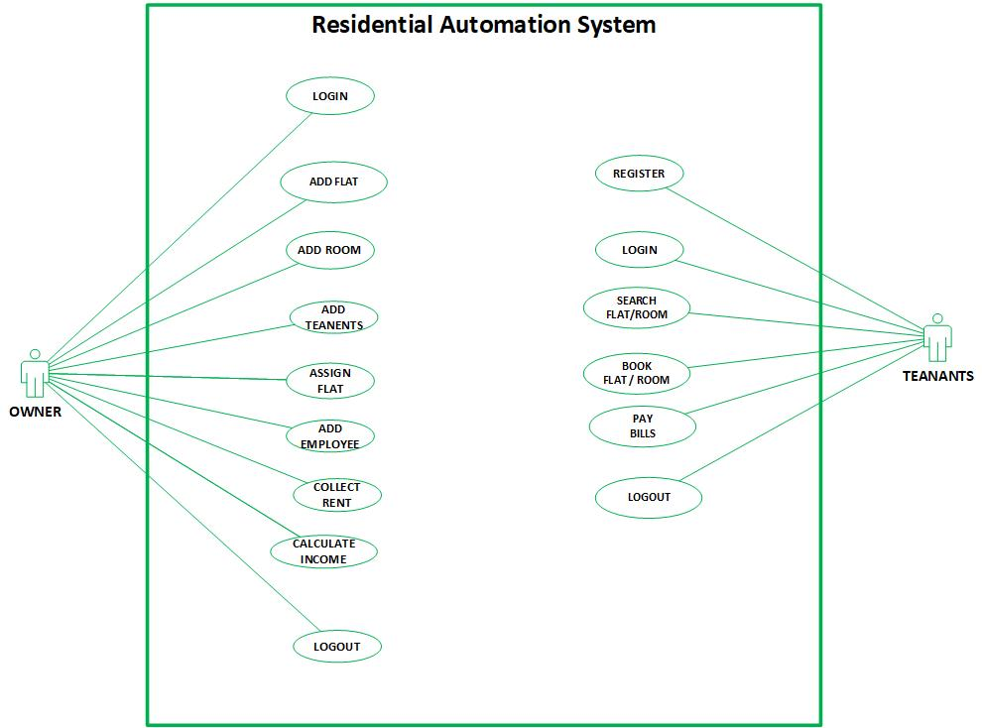
Use Case Diagram(s):

USAGE SCENARIOS:
REGISTER:

Use Case id | 1
Use Case title | REGISTER
Description | All customers/teanants who wants to book a room or flat must have to register himself on this website.
Pre-condition | Application interface must be available.
Action | - Open application interface of create account  - Fill the form of registration  - Click on “Register” button to get registered
Post Conditions | Customers/Teanants successfully created in database.
Alternative Path: | Customers/Teanants may not want to register this time
Exception: | If the user entered invalid data in the form then the exception occurs “Fill mandatory Fields”
Authority | Teanants/Customer
Author | Bc200405760 (Muqaddas) Bc200405764 (Amina)

LOGIN:

Use Case id | 2
Use Case title | LOGIN
Description | All stakeholders/Actors of the website must have to login to use some key features of this website.
Pre-condition | Actors must be registered with our website , Application interface must be available
Action | - Open application interface of login  - Enter user name and password  - Click on “Login” button
Post Conditions | Actors successfully login and able to further work
Alternative Path: | Actors may not want to login this time
Exception: | If the user entered invalid data in the form then the exception occurs “Invalid user name and password”
Authority | Owner , Teanant
Author | Bc200405760 (Muqaddas) Bc200405764 (Amina)

ADD FLAT:

Use Case id | 3
Use Case title | ADD FLAT
Description | This use case allows owner of the system to add flat which is later on available on our website for booking.
Pre-condition | Onwer user of the system must be registered with our website and logged in.
Action | - Login as Owner  - Fill add flat form  - Click on “Add Flat” button
Post Conditions | Flat successfully added and available to tenants for booking
Alternative Path: | -
Exception: | If the user entered invalid data in the form then the exception occurs “Please enter correct and valid data”
Authority | Owner
Author | Bc200405760 (Muqaddas) Bc200405764 (Amina)

ADD ROOM:

Use Case id | 3
Use Case title | ADD ROOM
Description | This use case allows owner of the system to add room which is later on available on our website for booking.
Pre-condition | Onwer user of the system must be registered with our website and logged in.
Action | - Login as Owner  - Fill add room form  - Click on “Add Room” button
Post Conditions | Room successfully added and available to tenants for booking
Alternative Path: | -
Exception: | If the user entered invalid data in the form then the exception occurs “Please enter correct and valid data”
Authority | Owner
Author | Bc200405760 (Muqaddas) Bc200405764 (Amina)
ADD TEANANT:

Use Case id | 4
Use Case title | ADD TEANANT
Description | All customers/teanants who wants to book a room or flat must have to register himself on this website. Owner has the authority to add any teanunts any time
Pre-condition | Application interface must be available. And system must be logged in as Owner
Action | - Open application interface of create account  - Fill the form of add teanunt  - Click on “Add Teanuant” button to get registered
Post Conditions | Customers/Teanants successfully created in database.
Alternative Path: | Owner may not want to add teanunt this time
Exception: | If the user entered invalid data in the form then the exception occurs “Fill mandatory Fields”
Authority | Owner
Author | Bc200405760 (Muqaddas) Bc200405764 (Amina)

ASSIGN FLAT:

Use Case id | 5
Use Case title | ASSIGN FLAT
Description | This usecase is for all customers/teanants who makes the request to book a room or flat. Owner has the authority to assign the flat to teanant any time
Pre-condition | Application interface must be available. And system must be logged in as Owner
Action | - Open application interface of create account  - View all booking requests  - Assign room no or flat no to the requested customer
Post Conditions | Customers/Teanants successfully created in database.
Alternative Path: | Owner may not want to add teanunt this time
Exception: | If the user entered invalid data in the form then the exception occurs “Fill mandatory Fields”
Authority | Owner
Author | Bc200405760 (Muqaddas) Bc200405764 (Amina)

ADD EMPLOYEE:

Use Case id | 6
Use Case title | ADD EMPLOYEE
Description | This use case is about adding an employee who will work for the customers
Pre-condition | Application interface must be available. And system must be logged in as Owner
Action | - Open application interface of create account  - Fill the form of add employee  - Click on “Add Employee” button to add employee
Post Conditions | Employee successfully created in database.
Alternative Path: | Owner may not want to add empoyee this time
Exception: | If the user entered invalid data in the form then the exception occurs “Fill mandatory Fields”
Authority | Owner
Author | Bc200405760 (Muqaddas) Bc200405764 (Amina)

COLLECT RENT:

Use Case id | 7
Use Case title | COLLECT RENT
Description | This use case is about collecting rent from customers
Pre-condition | Application interface must be available. And system must be logged in as Owner
Action | - Open application interface of create account  - Check rent of all the teanants living in the block  - Collect rent from those whose rent is due
Post Conditions | Rent collected and deposited in finance department
Alternative Path: | -
Exception: | If the rent is not due this use than rent is not collected
Authority | Owner
Author | Bc200405760 (Muqaddas) Bc200405764 (Amina)

SEARCH ROOM:

Use Case id | 8
Use Case title | SEARCH ROOM
Description | This use case allows users to view/search the desired room/flat that are available on this system
Pre-condition | Application interface must be available
Action | - Open application interface and fill the criteria of search room/flat.  - Click on the “SEARCH” button
Post Conditions | All rooms/flats that fall on the search criteria will be displayed on the website
Alternative Path: | Customers may not want to search room/flat this time
Exception: | If none of the room or flat is available in the database no item will be displayed.
Authority | Customer/teanunt
Author | Bc200405760 (Muqaddas) Bc200405764 (Amina)

BOOK ROOM:

Use Case id | 9
Use Case title | BOOK ROOM
Description | This use case allows users to book the desired room/flat that are available on this system
Pre-condition | Application interface must be available
Action | - Open application interface and fill the criteria of search room/flat.  - Select Room you want and click on book room
Post Conditions | Room booking request will be sent to owner of system
Alternative Path: | Customers may not want to book room this time
Exception: | If user is not logged in this feature is not available.
Authority | Customer/teanunt
Author | Bc200405760 (Muqaddas) Bc200405764 (Amina)

LOGOUT

Use Case id | 10
Use Case title | LOGOUT
Description | This use case allows all the actors of the system to logout from website.
Pre-condition | The application interface must be available and any of the actor must be Logged in.
Action | - Open application interface.  - Click on Logout Button.
Post Conditions | Session is destroyed and actor will be logout from system.
Alternative Path: | Force close website.
Exception: | If session is empty than this feature is not available.
Authority | Owner, Customer/teanunt
Author | Bc200405760 (Muqaddas) Bc200405764 (Amina)

Adopted Methodology
Development of any software product or application choice of right model is very important. The selection of model has very high impact on the testing that is carried out. It will define that what, where and when of our planned testing, influence regression testing and which test techniques to use. The development models are the various processes or methodologies that are being selected for the development of the project depending on the project aims and goals. There are many development life cycle models that have been developed in order to achieve different required objectives. The models specify the various stages of the process and the order in which they are carried out There are various Software development models or methodologies we discus Water Fall and Spiral Model in the following.

Waterfall Model:
The waterfall Model is a linear sequential flow. In which progress is seen as flowing steadily downwards (like a waterfall) through the phases of software implementation. This means that any phase in the development process begins only if the previous phase is complete. The waterfall approach does not define the process to go back to the previous phase to handle changes in requirement. The waterfall approach is the earliest approach that was used for software development.
Diagram
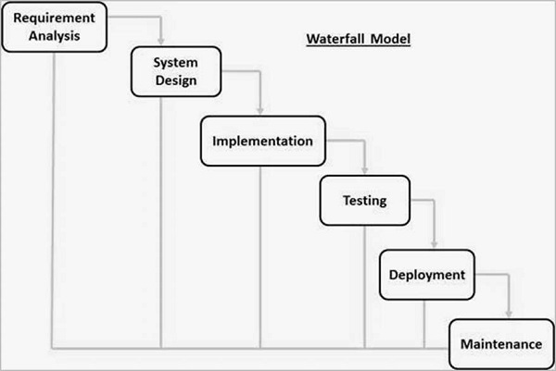
Spiral Model:
The spiral model is similar to the incremental model, with more emphasis placed on risk analysis. The spiral model has four phases: Planning, Risk Analysis, Engineering and Evaluation. A software project repeatedly passes through these phases in iterations (called Spirals in this model). The baseline spiral, starting in the planning phase, requirements are gathered and risk is assessed. Each subsequent spirals builds on the baseline spiral.
Planning Phase:
Requirements are gathered during the planning phase.
Risk Analysis:
A prototype is produced at the end of the risk analysis phase. If any risk is found during the risk analysis, then alternate solutions are suggested and implemented.
Engineering Phase:
In this phase software is developed, along with testing at the end of the phase. In this phase the development and testing is done.
Evaluation phase:
This phase allows the customer to evaluate the output of the project to date before the project continues to the next spiral.
Diagram of Spiral model:
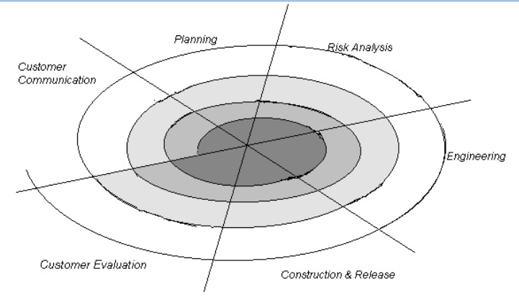
VU Process Model:
The methodology chosen for this project is VU Process Model. The vu process model, offers numerous advantages for software developers and because of its beneficial flow I use this methodology. This model is a combination of Waterfall and Coiled/Spiral Model. This is a hybrid approach of system development, which maximizes the quality of system and minimizes the disadvantages and risks.
VU process model has four phases; each phase is tested on its completion. It
conserves resources and is superlative for sustaining less skilled plan teams and project managers whose composition fluctuates. The errors are removed due to iteration to previous or next phases. The orderly sequence of development steps and strict controls for ensuring the adequacy of documentation and design reviews helps ensure the quality, reliability, and maintainability of the developed software. The progress of system development is measurable.VU Process model depicts the linear nature of waterfall and iterative risk analysis of spiral. We analyze each phase activity with the end product. VU Process model will help us in identification of risk at the time as it omits. So resolution of that risk will be much easy at that point, while if it is detected at later stage then the resolution will become much more painful and costly (time& budget). Also documentation makes the maintenance of product after its delivery easy. So by combining the spiral & waterfall we get the benefits of waterfall and risk sensitivity of the spiral.
REASONS FOR CHOOSING THE METHODOLOGY
- The Waterfall Model is a documentation-driven model. It therefore generates complete and comprehensive documentation and hence makes the maintenance task much easier. Documentation helps to keep track to risk.

- It suggests a systematic, sequential approach to software development that begins at the system level and progresses through the analysis, design, coding, testing, and maintenance.
Vu Process Model Diagram;
Analyzing & Gathering requirement

Planning Phase

Analysis & Design Phase

Development Phase

Operation & Maintenance
Analysis and Design Phase
Development Phase
Operation & Maintenance

Work Plan (Use MS Project to create Schedule/Work Plan)

SRS AND DESIGN DOCUMENT
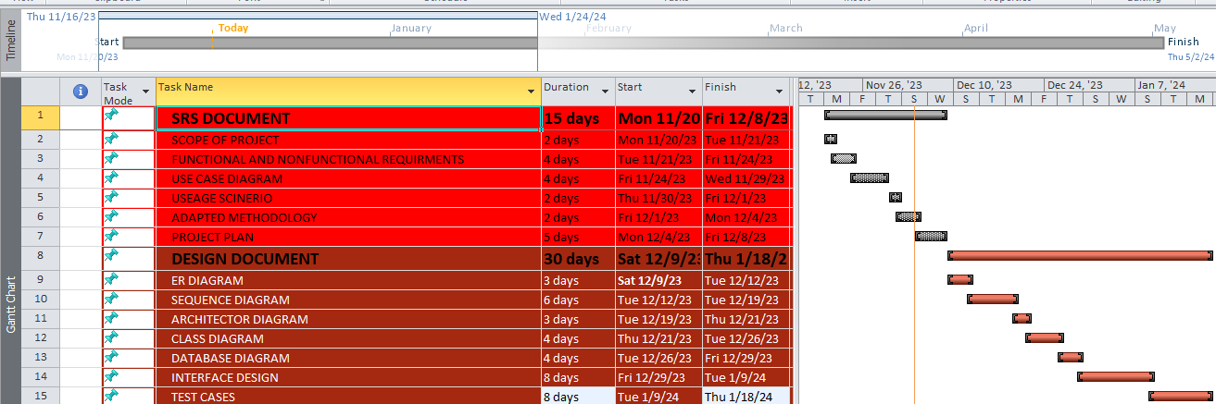

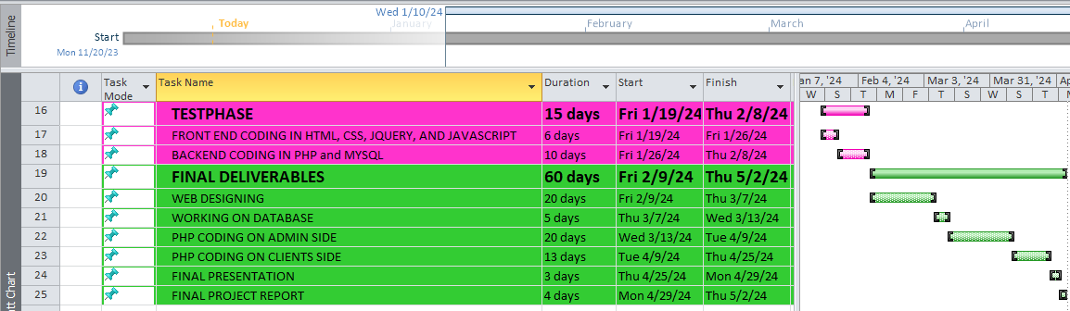
TESTPHASE AND FINAL DELIVERABLES

